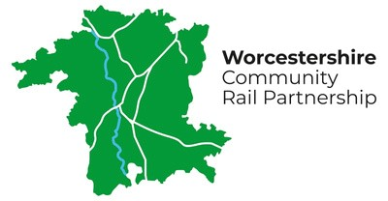
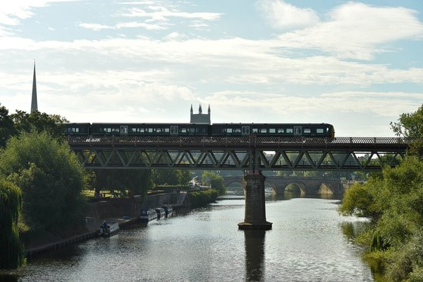
IMPACT REPORT
2025
ACCESSING THE FUTURE

Celebrating people, powering progress, opening
journeys for all.
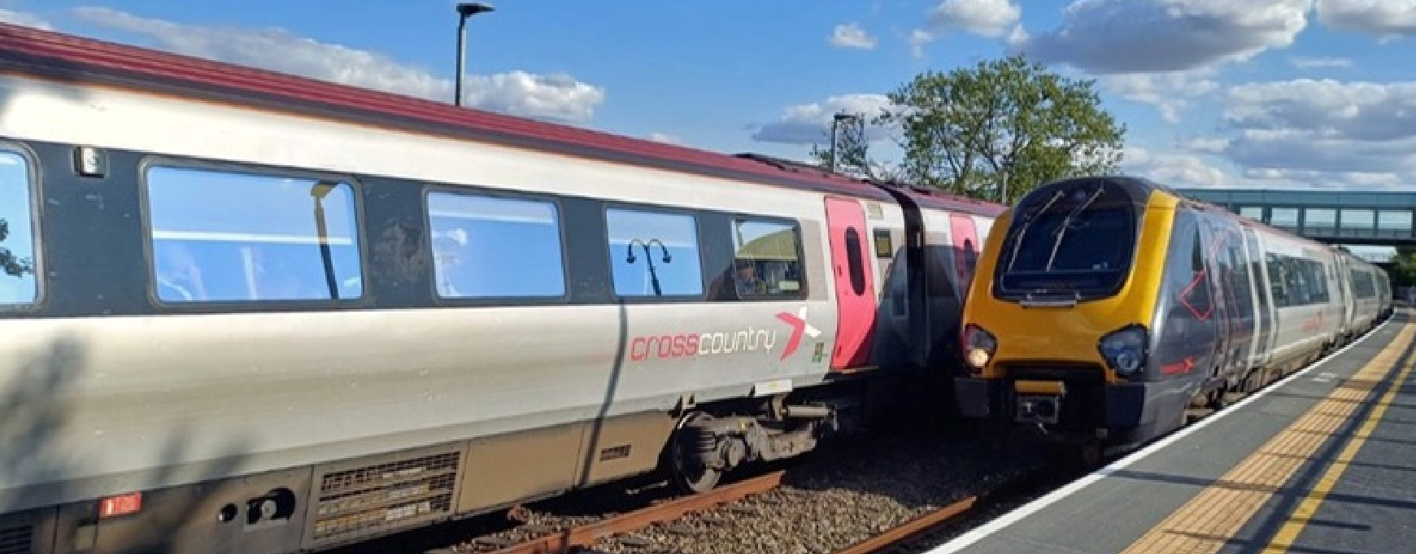
ABOUT US
Who we are and what we do......................................................................................................3
Welcome
from the Chair.............................................................................................................4
Year at a glance..........................................................................................................................5
PROVIDING A VOICE FOR THE COMMUNITY

Station Adoption Work Summary &
William Whiting Memorial Bench....................................6
PROMOTING SUSTAINABLE, HEALTHY, AND ACCESSIBLE TRAVEL
Rail Trails......................................................................................................................................7
Platform Rail Education.............................................................................................................8
BRINGING COMMUNITIES TOGETHER, SUPPORTING DIVERSITY AND INCLUSION
W
orcestershire Parkway Skeps...................................................................................................9
Walkers are welcome- Evesham Launch....................................................................................10
Shrub Hill 175................................................................................................................................11

SUPPORTING SOCIAL AND ECONOMIC DEVELOPMENT
Rail to Ale Worcester....................................................................................................................12
THE YEAR AHEAD
Financial Overview........................................................................................................................13
Looking Ahead..............................................................................................................................14
CLOSING REMARKS
Partners & Collaborations...........................................................................................................15
Contact Us.....................................................................................................................................16
CONTENTS
2
Photo Caption: Cross Country Trains at Worcestershire Parkway

WHO WE ARE ³
About us:  What we value:  Our vision for the Future: | Worcestershire Community Rail Partnership gives a voice to local people and strengthens community involvement in their railway.  We promote rail as a sustainable, accessible, and healthy way to travel — seamlessly connected with other transport options — meeting the needs of residents, businesses, and visitors while helping create greener, more connected communities.  We bring together diverse and inclusive communities, building confidence in using rail and public transport. Through attractive stations, engaging visitor  experiences, and support for social enterprise, we help unlock the social, economic, and tourism potential of rail travel across Worcestershire.  Connectivity • Community Empowerment • Inclusivity • Sustainability  “A Worcestershire where station corridors become thriving green pathways, seamlessly connecting people, nature and opportunity.”
& WHAT WE DO

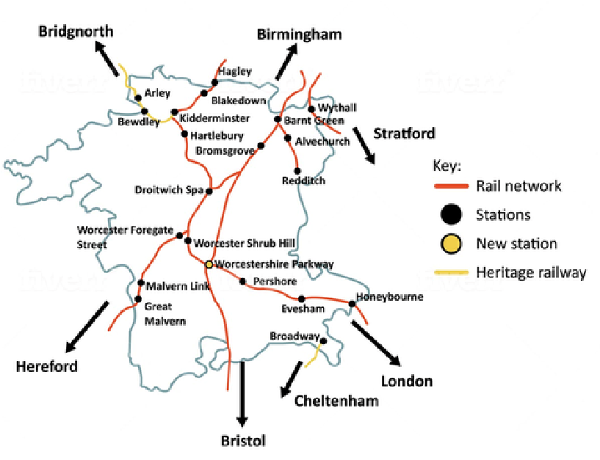

WELCOME FROM THE CHAIR
4
I am delighted to introduce this, the first-ever impact report for the Worcestershire Community Rail Partnership. And in this bicentennial year for the railways, ‘accessing the future’ feels more than appropriate as a theme.
The railways changed people’s lives in every conceivable way. They standardised time across the country, spurred economic growth, and facilitated social change. They also helped to make Worcestershire into what it is today.
It was therefore apt that the celebrations for Railway 200 started at Kidderminster’s Severn Valley Railway with a visit from the Inspiration Train, a moving exhibit dedicated to educating and interesting young people in the railway. This complemented the school outreach program, supported by long-term partner Platform.
Over-18s were well catered for with the launch of the County’s first rail-ale trail. Created in collaboration with CAMRA, it promoted both rail travel and Worcester’s vibrant hospitality scene. And what better way to build up a thirst than by taking one of the station-to-station walks, especially one of the new circular routes added to our ongoing successful Rail Trails during 2025. At many of the stations, you can appreciate the efforts of the adopters and volunteers who work so tirelessly to embed stations within the communities that they serve.
We have an ambitious programme of activities planned for 2026, some building on the successes of the past 12 months, others bold new ideas. All will be focused on harnessing rail’s power to connect people to each other; businesses to markets, and job seekers to opportunities, offering sustainable travel to create a

stronger, happier, healthier, and more prosperous Worcestershire.
-Tom Painter
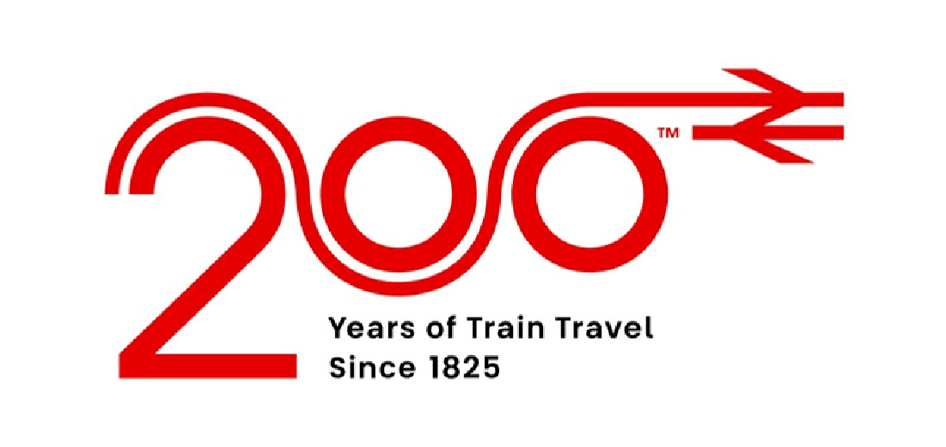
YEAR AT A
GLANCE
5
Projects Delivered
Stations Adopted
Students Engaged
Collaborations
with Partners
Volunteers
1,890
14
12
20
43

STATION ADOPTION
6
2025 has seen another busy year for our station adopters who have been working hard on all kinds of different stationrelated activities, including gardening, history, art, and community engagement.
We have welcomed new adopters at Evesham, Blakedown, and Hartlebury, who are enthusiastically looking at ways to improve aspects of the stations and connect them further with their communities.
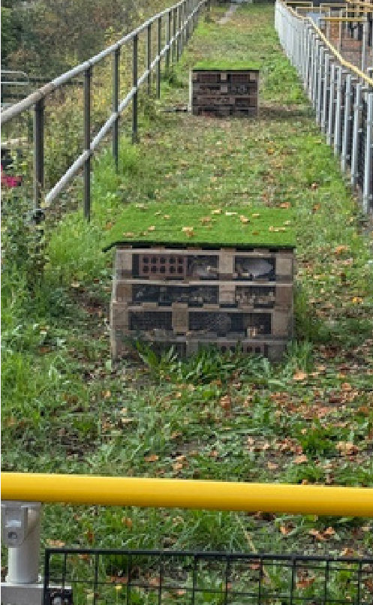
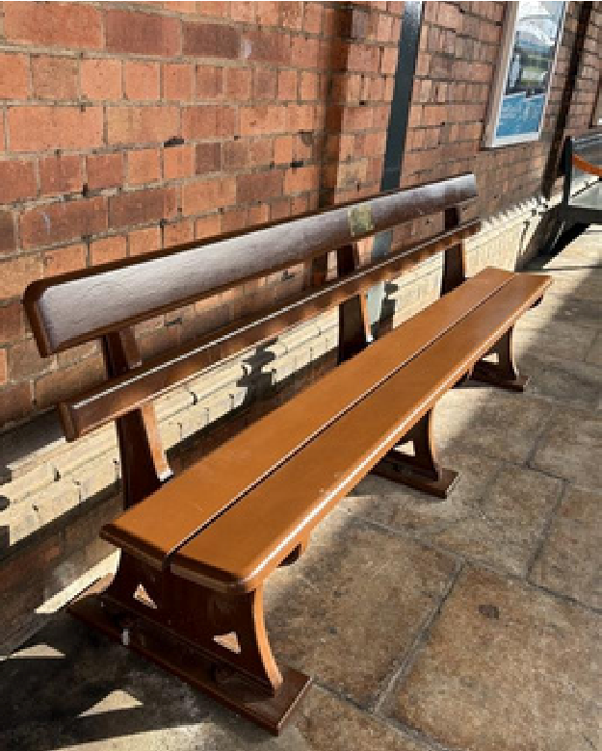
Photo Caption: 2 Bug Hotels at adopted station

A DEDICATION TO WILLIAM
Photo Caption: William’s memorial bench at station.

A bench has been installed at Worcester Foregate Street Station in memory of William Whiting. William was an enthusiastic champion of rail travel and the inaugural Chair of Worcestershire Community Rail Partnership. He remained an active and positive influence on the organisation until his sad and unexpected passing in January 2023.
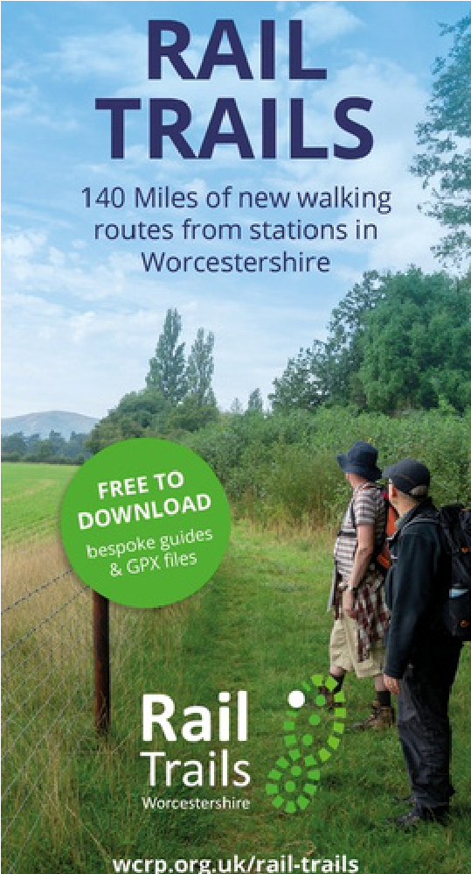

RAIL TRAILS
We have continued to extend our suite of popular Rail Trails with new routes on the Herefordshire side of the Malvern Hills.
We have been busy promoting our walks this year with several activities, including:
- An event during National Walking Month at Worcestershire Parkway with Lyndon Bracewell, our partner from Worcestershire Ramblers.
- Updating and distributing our Rail Trails leaflet, kindly funded by CrossCountry Trains.
- Producing a short film showcasing our Malvern Hills circular walk in collaboration with GWR and Malvern Hills District Council.
Photo Caption: Lyndon Bracewell handing out leaflets
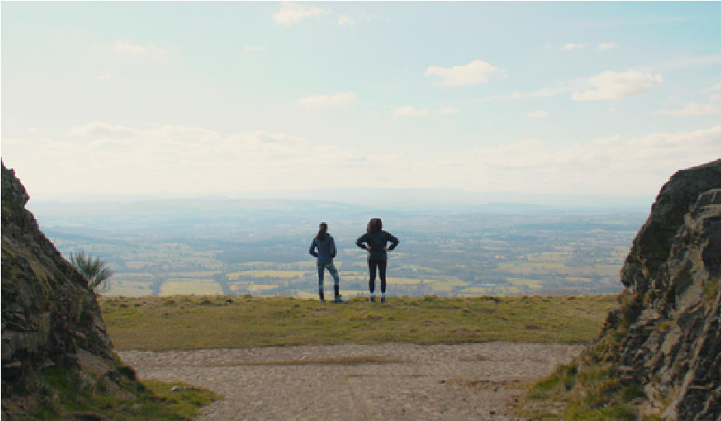
Photo Caption: View from the top of Malvern Hills 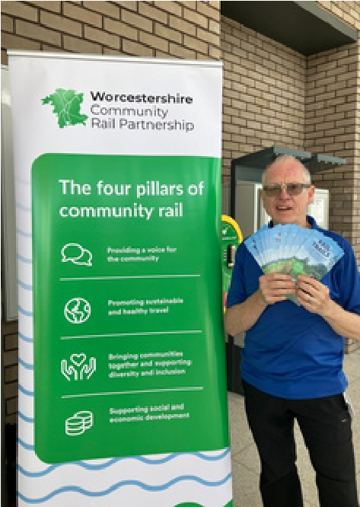
7

PLATFORM RAIL EDUCATION
The Platform Rail educational programme has delivered a significant and lasting impact across schools and educational communities within Worcestershire.
Through interactive workshops, curriculum-linked resources, and immersive station-based learning experiences, the programme has inspired young people to engage with rail travel, sustainability, and local heritage in a meaningful way.
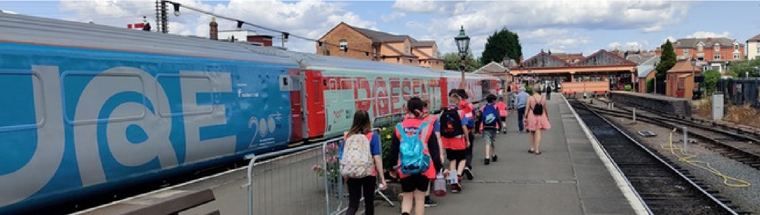
Teachers have regularly reported improved student understanding of transport safety, employability pathways, and environmental responsibility.
Photo Caption: Children leaving the inspiration train
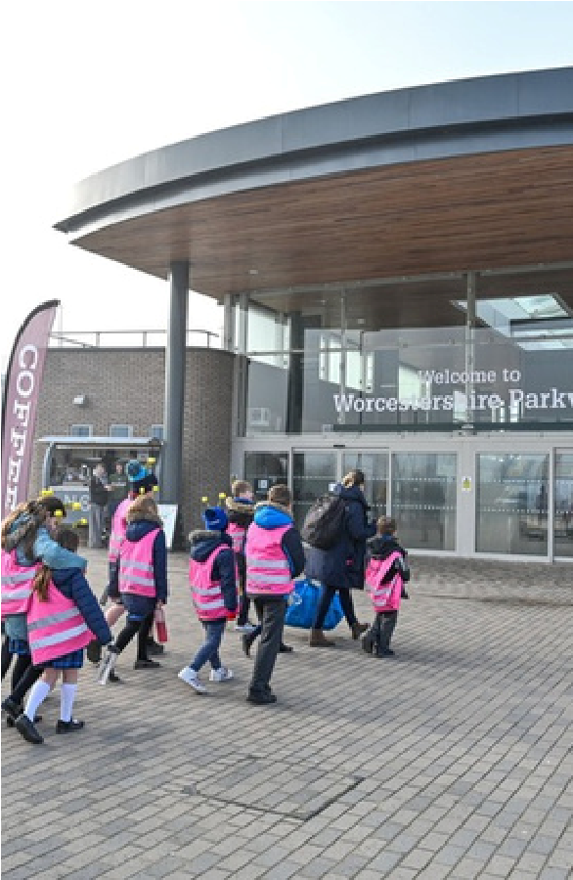
8
Photo Caption: School children walking into the station
By connecting education with the local rail network, Platform has strengthened community links, promoted inclusive learning, and fostered a sense of pride and ownership among young residents in Worcestershire’s railway community.

WORCESTERSHIRE PARKWAY SKEPS
Photo Caption: School children posing in front of station artwork

In spring, we delivered a unique public display of bee-friendly skeps —traditional beehives reimagined through creative, sustainable designs.
The project was carried out in partnership with Platform (rail education scheme), the Bee Friendly Trust, the Community Rail Network, and train operator Great Western Railway.
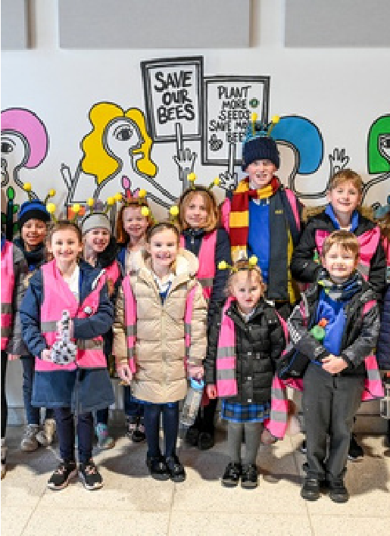
Eight decorated bee skeps were installed at the station, designed by a combination of local schoolchildren and professional artists to raise awareness of bee conservation along the railway network.
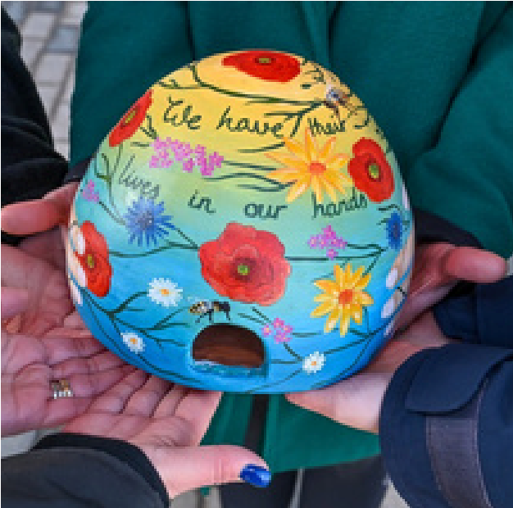
Photo Caption: Colourful Bee Hive/Skep
Worcestershire CRP received £1,000 from the Community Rail Development Fund to host educational workshops for students from Norton Juxta Kempsey CofE Primary School and Honeybourne Primary School.
The students participated in three workshops, where they learned about the importance of bees in ecosystems and took part in hands-on gardening activities at the station.
The project successfully combined education, community engagement, and public art to promote bee conservation and enhance the station environment.
9
WALKERS ARE WELCOME -
Photo Caption: John Clatworthy
cutting ribbon

EVESHAM LAUNCH
Evesham’s rich history and beautiful surroundings make it a popular destination for walkers. Following a successful bid in 2023 by Evesham Rambling Club to gain Walkers are
Welcome status, Worcestershire Community Rail Partnership worked in partnership with club members and town leaders to promote walks from the railway station.
Walkers are Welcome is a nationwide initiative that supports ‘members to assist with their communities’ economic, physical health and mental well-being through walking’. Working together, the partners could encourage accessing the town’s many walks by using a sustainable form of transport while promoting the town as a walking-friendly destination.

Photo Caption: Fiona and walking group
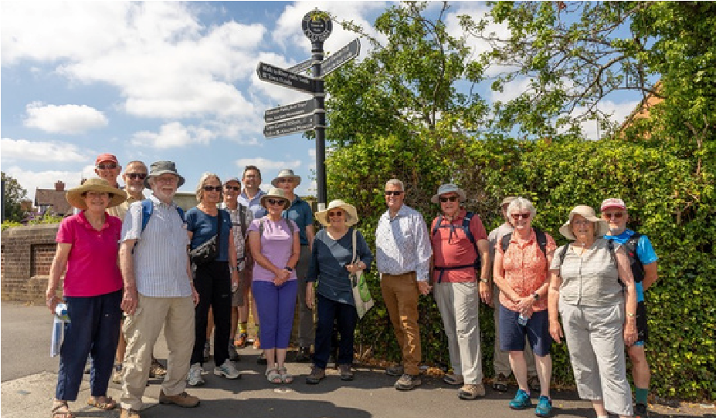

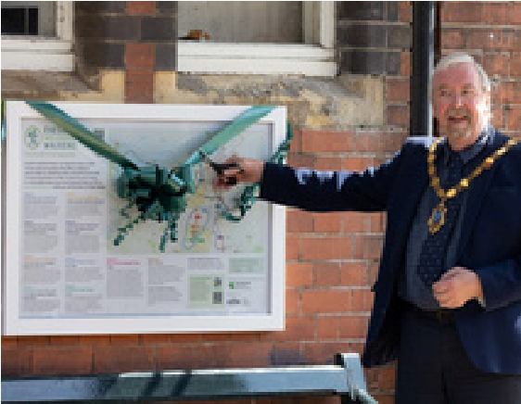

The partners agreed that the creation, installation and promotion of two walking map boards at Evesham Station would not only attract walkers to the town but also encourage arrival by train rather than by car.
The boards would display walking routes created by the Evesham Rambling Club and also include Worcestershire
Community Rail Partnership’s Rail Trail from Evesham Station.
The boards were launched by holding an event at the station where partners, local dignitaries and ramblers would arrived by train to view the maps and walk one of the routes.

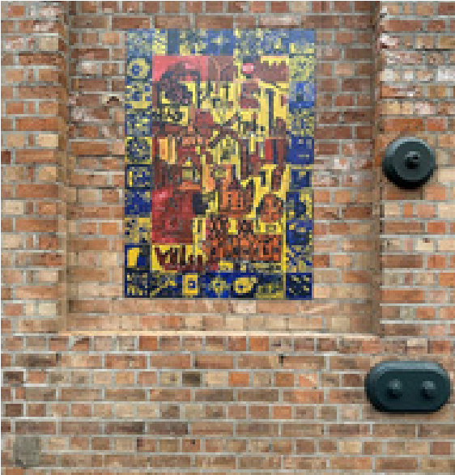
SHRUB HILL 175 SCHOOL ART PROJECT
This year marked a special milestone for Worcester Shrub Hill Station — 175 years of serving the local community. The station remains an important gateway to the city and county today. To celebrate this anniversary, we partnered with local artist Claire Horacek to create three new pieces of artwork for Platform 2, inspired by Shrub Hill’s unique ironwork and historic decorative tiles.
Photo Caption: School artwork
installed on the wall at the station
Three local primary schools took part in the project — Martley C of E Primary School, St George’s C of E Primary
School, and St Barnabas Primary School — engaging a total of 90 pupils. The children began by visiting Shrub Hill Station with Claire, where they explored its architecture, looked closely at the traditional tilework, and discovered how the old signalling system once operated.

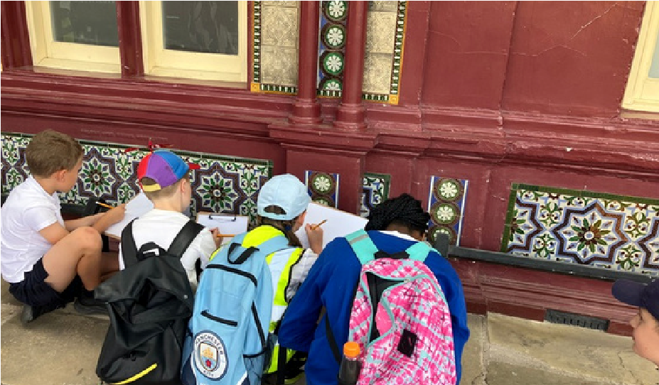
Photo Caption: School children drawing tiles at the station

Photo Caption: School artwork installed on the wall at station
The visit encouraged them to see the station not just as a place to catch a train, but as a piece of living history within their community. Claire then visited each school to run hands-on workshops, where the children painted and designed their own tiles. These individual pieces were brought together into three colourful panels celebrating both Worcester’s heritage and the children’s creativity.
This community project — delivered with the support of West Midlands Trains — helped pupils connect art, local heritage, and the rail network in a meaningful way. It not only celebrates Shrub Hill’s 175-year history but also inspires the next generation to see their local station as a place of pride, creativity, and connection.

RAIL TO ALE TRAILWORCESTER
The Worcestershire Community Rail
Partnership launched the Worcester Rail to Ale Trail as a creative new initiative to promote sustainable leisure travel by train, support local pubs, and encourage visitors to explore Worcester’s city centre.
Running from August to September 2025, the trail linked 12 independent pubs and breweries across Worcester through a free leaflet and stamp card. Participants travelled by train, collected stamps as they visited each venue, and received a limited-edition Rail to Ale badge as a memento upon completing the trail.
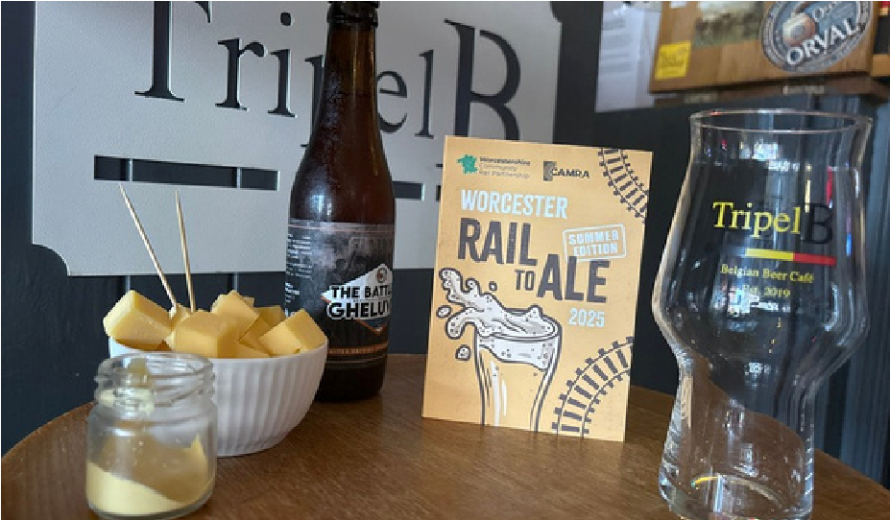
The project showcased Worcester’s thriving hospitality scene while reinforcing rail as the gateway to great local experiences. It was delivered in partnership with CAMRA and the participating pubs, with promotion extending beyond Worcestershire through social media, printed literature, and tourism channels.
Photo Caption: Leaflet featured at TripelB pub in Worcester
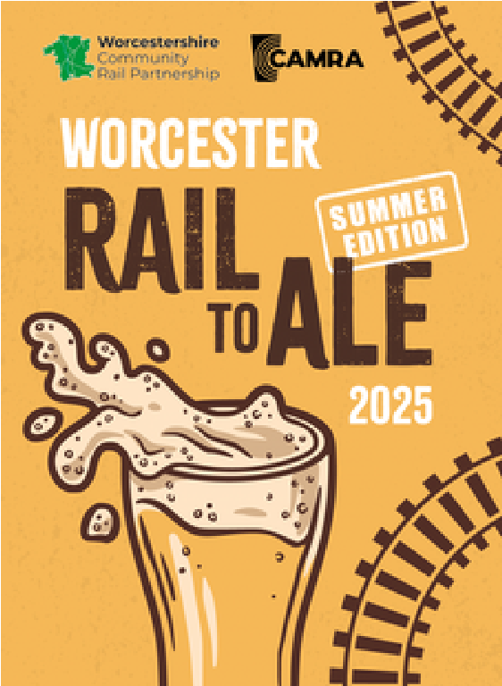

Photo Caption: Rail to Ale Leaflet
90 website visits generated to the Rail to Ale Page
The Rail to Ale Trail demonstrated the power of community rail to bring people together, support local business, and inspire lowcarbon tourism through creative, place-based experiences


FINANCIAL OVERVIEW
In the financial year April 2024–March 2025, the partnership generated a total income of £220,233.21. Actual expenditure amounted to £112,377.43, leaving a healthy carry forward of £107,855.78.
During this period, we also established a reserve and contingency fund of £17,142.50, ensuring financial stability.
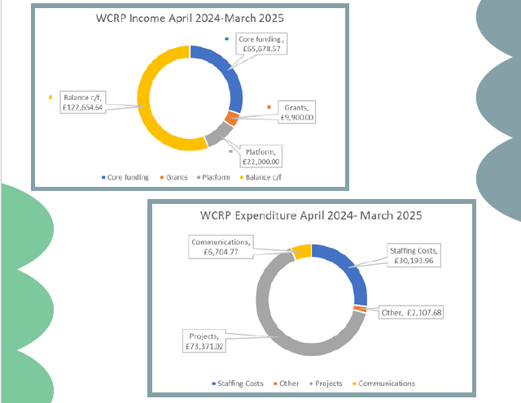
Thanks to the generous support of our partners and WCRP’s careful financial management, coupled with the addition of a second Partnership Officer, we are now well-positioned to expand our impact and deliver on our ambitious plans for the year ahead. Since April 2025, we have been making steady inroads into our financial surplus by delivering the activities outlined in this report— translating our strong financial foundation into meaningful community outcomes. With this momentum, WCRP is ready to turn its vision for the coming year into reality.

LOOKING AHEAD
14
In 2026, we aim to:
In 2026, Worcestershire Community Rail Partnership will continue to strengthen the role of rail at the heart of our communities.
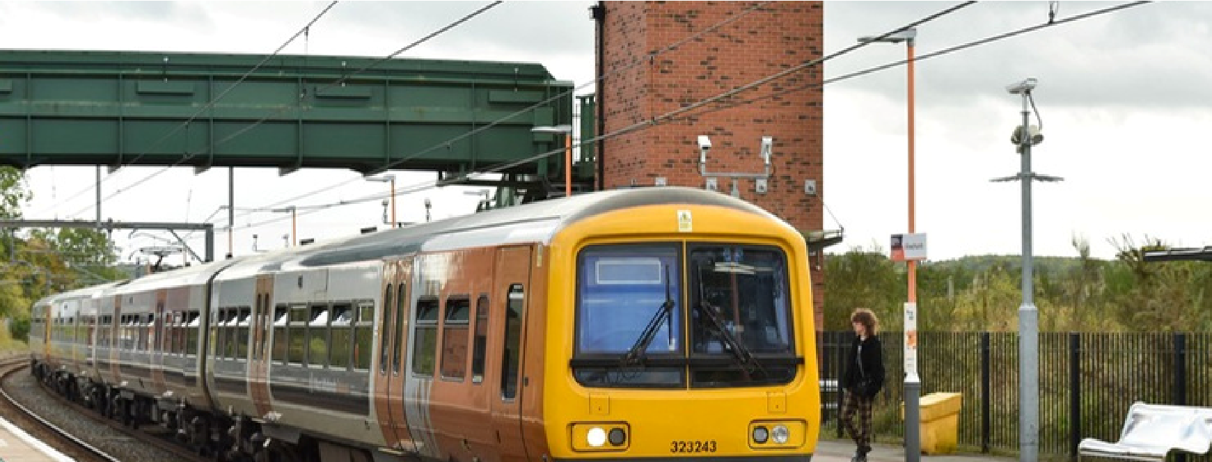
Our aims are to expand opportunities for people to travel sustainably and confidently by train, deepen partnerships with schools, local groups, and station adopters, and further develop stations as welcoming gateways to their towns and countryside.
We’ll continue to celebrate Worcestershire’s rich heritage while looking to the future—supporting greener travel choices, promoting local tourism, and helping more people see rail as a vital part of everyday life.

Photo Caption: West Midlands Train at Alvechurch Station
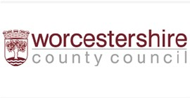
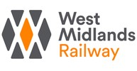

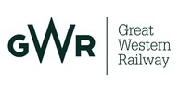

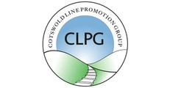
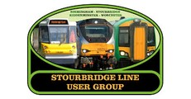
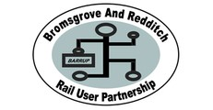


PARTNERS &
COLLABORATIONS
We’d like to say a heartfelt thank you to all our
partners, supporters, and volunteers who’ve
worked alongside us throughout 2025. Your ideas,
energy, and collaboration have helped us bring
communities closer to their railways, improve local
stations, and promote sustainable travel across
Worcestershire. Every project we deliver is stronger
because of the people and organisations who share
our passion for connecting people, places, and
opportunities.
15
WCRP Officers: Hayley Cartwright & Fiona Saxon
Email: enquiries@wcrp.org.uk
CONTACT US
16
Website: wcrp.org.uk platformrail.org

Socials: @worcscrp
